**Institute of Technology Tralee**

**BSc. in Computing with Specialism (Group D) - Year 1**

**Continuous Assessment #1**

**Date: 18/10/11**

**Time: 3 – 5 p.m.**

**Introduction to Programming**

**Instructions:** Attempt the following question. You should use the Just BASIC IDE for coding. When you are finished you must print out your code for correction.

**________________________________________________________**

**Q1.**

The two most commonly used temperature scales in everyday life are the Celcius and Fahrenheit scales. It is possible to convert between the two scales using the following formulae:

and

Write a program that begins by presenting the user with 3 options as follows:

1. Convert from Celcius to Fahrenheit
2. Convert from Fahrenheit to Celcius
3. Display the Current Temperature in both Celcius and Fahrenheit

The user is prompted for their choice (1,2 or 3) and, having entered their choice, the screen clears. If option 1 is picked, the user will be asked for the temperature in Celcius and it will be converted to Fahrenheit. If option 2 is picked then the user will be asked for the temperature in Fahrenheit and it will be converted to Celcius. If option 3 is picked, the program just displays the current temperature in Celcius and Fahrenheit – for the purposes of this program, you can just assume that the current temperature is 14 Celcius and this equates to 57.2 Fahrenheit and display these two values directly (no formula needs to be used in this case).

Your program should have an element of **error-detection** in it also. If option 1 is chosen and the user enters an invalid Celcius temperature (any value less than -273), then an appropriate error message should be given and the program should immediately terminate without doing any calculations at all.

The calculated temperatures from option 1 and 2 should be displayed correct to **2 decimal places** and the program should **allow for at least 5 digits to be displayed before the decimal point** without incurring a logical error.

Using the test values as indicated in the screen shots below, the program should give you **exactly** the following output when it runs, including banners, blank lines, units etc.

Also note that there will be a few marks awarded for the use of **meaningful variable names**, having a **meaningful comment at the top of the program** and for **proper indentation** in the coding of the program. Also, some marks will be awarded for **efficient** coding and for ensuring that the program is **terminated correctly** to ensure that all resources used by the program are returned to the system upon its completion.

**Sample Screen Shots**

**When the program runs the user is presented with the following:**

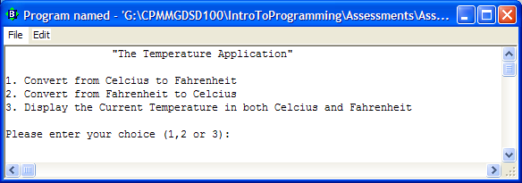

**If the user enters 1 the screen clears and they are then asked for a Celcius temperature – in this case the temperature is invalid so an error message is given and the program terminates**

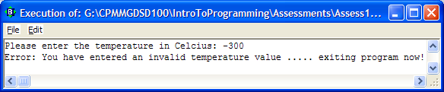

**In this run the Celcius temperature is valid, the conversion is performed and the result displayed**

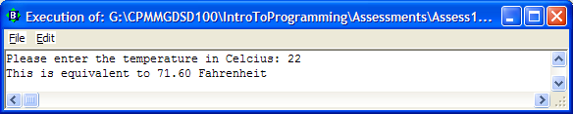

**In this run the user has chosen option 2, enters 100 for the Fahrenheit temperature, the conversion to Celsius is performed and the result displayed**

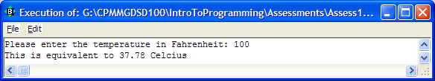

**In this run the user has chosen option 3 so the screen clears and the current temperature in Celcius and Fahrenheit, which we are just assuming are 14 Celcius and 57.2 Fahrenheit, are displayed**

